1602A Display Project Notes
Christopher Kalitin

Posts
LED Debugging breadboard:
https://x.com/CKalitin/status/1864882097003073865

Kanye lyrics:
https://x.com/CKalitin/status/1865892778745708866

Yapping with some screenshots:
https://x.com/CKalitin/status/1893926626343125185

PCBs arrived:
https://x.com/CKalitin/status/1896837361780367451

Screw doesn’t line up:
https://x.com/CKalitin/status/1901323343388889518

China money:
https://x.com/CKalitin/status/1902207889810563331

Soldering at night is a vibe tbh:
https://x.com/CKalitin/status/1905870344843587714

MOSFET with jumpers:
https://x.com/CKalitin/status/1905889097996276224

STM32 chips don’t actually pull high (David Palmer is a legend):
https://x.com/CKalitin/status/1906086305278353666
PCB Order:
https://x.com/CKalitin/status/1920617592102019336

Project Complete:
https://x.com/CKalitin/status/1924710105318301832

Dec 2 2024
Nucleo 32 STM links:
AMAZING Datasheet: https://www.st.com/resource/en/datasheet/stm32f031k6.pdf

STM32 ADC Calibration (Very low level hardware mostly, not for nucleo type boards): https://www.st.com/resource/en/application_note/cd00211314-how-to-get-the-best-adc-accuracy-in-stm32-microcontrollers-stmicroelectronics.pdf

Quick start guide: https://www.st.com/en/evaluation-tools/nucleo-f031k6.html

Datasheet (shitty): https://www.st.com/en/evaluation-tools/nucleo-f031k6.html

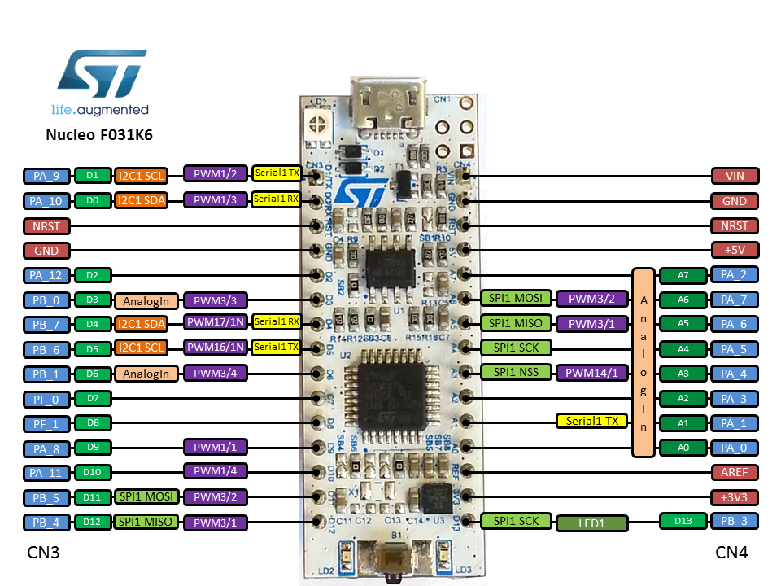

1602A LED Display Documentation: https://www.technologicalarts.ca/support/docs/Components/OLED1602A/SOC1602A.pdf

Great tutorial series: https://www.youtube.com/watch?v=Hffw-m9fuxc&list=PLNyfXcjhOAwO5HNTKpZPsqBhelLF2rWQx&index=3

Likely better datasheet: 1602a docs https://www.crystalfontz.com/products/document/964/CFAH1602XYYHJP_v2.0.pdf

Mar 18 2025 - MOSFETs Part 1

N-channel: Source to GND P-channel: Source to 5V N-channel: control ground path P-channel: control power path Oh no!

So i used the mosfet wrong, and the pot was the wrong value

datasheet recommends a 10k btw (page 12)

It doesn't support switching ground on and off
Also, doing this means it tries to use a GPIO as ground and doesn't turn off for some reason

Also, I can't use an n channel mosfet to switch pos, so im out of luck

More context: With pos still on but gound disconnected, the display is still on, so ground is somewhere else, probably a GPIO.

Mar 28 2025 - More MOSFET Research
More MOSFET research:

High-side switching:
- PSU voltage controlled
- device default grounded
- requires higher voltage than pos to drive switch

Low-side switching:
- GND is controlled
- device default high voltage
- gate voltage referenced to ground (gate can be lower than for high-side).

N-channel:
- Conducts when positive voltage applied to gate relative to source
- Lower on-resistance than P-channel mosfets

N-channel for low-side switching:
- MOSFET between load and ground
- Source pin to GND
- Drain pin to load
- On with any voltage greater than 0 (+logic level high)

N-channel for high-side switching:
- MOSFET between load and source voltage
- Requires gate driver to generate switch voltage that's greater than source voltage.

P-channel:
- Conducts when gate is lower than source

P-channel in High-Side Switching:
- MOSFET between PSU and load
- Source connects to supply
- Drain connects to load
- To turn on, pull gate low
- To turn off, pull gate high

P-channel in Low-side switching:
- Drain to Ground, Source to load.
- Gate must be below source voltage to turn on
- Since source voltage is GND, you need a negative referenced voltage (eg. -5V)

I require a P-channel mosfet on 5V to Vdd of the display.

This means that if the microcontroller starts the power pin at ground, it would start the display (maybe unintentionally at startup).

The solution is a pull-up resistor.
This ensures the default value when the line is not driven by the microcontroller is 5V.
Then, the GPIO is enabled as GND and overrides this behavior. GPIOs are by default in a high-impedance state, so floating.

High-impedance = floating.

Since the GPIO is by default floating (check this assumption!), our pull-up resistor handles the startup and keeps the MOSFET off.
After the MCU is initialized, if the GPIO is put to GND, then it overrides the behavior of the pull-up resistor.
V = IR, eg. 10k resistor on 5V = 0.5mA. Lowish power draw, ensure the microcontroller can handle this power draw regardless, check datasheet.

The MCU might also have a default GPIO state (pull-up, pull-down, floating), if this is configurable the resistor may not be needed.

At startup I'd have to set the GPIO to high to ensure the display isn't turned on.
(Maybe you can set a default GPIO value?)

I should put all project notes into google docs, not discord

Might be an issue driving the MOSFET using a 3.3V GPIO:
https://grok.com/chat/eae9e307-45bf-4671-a945-f30021aedf59
(no)

Mar 29 2025 - Pull-up Resistor
Can't use STM32 to pull up:
https://x.com/CKalitin/status/1906086305278353666

- The issue was lack of a pull up resistor
- needed P channel mosfet, wrong potentiometers
- technically got drain and source wrong (was n channel)
- too small pads for mosfet
- display screw holes off
- mosfet pad fell off
- screw holes too small for most of my screws (I just eyeballed a size, didn't really care about this while designing)
- Burned the headers
- UART pins not available

Can't do low-side switching since the current flows through a GPIO somehow (internal 1602A circuitry?)

The contrast LED needs to be ~0.7V to GND for text to be visible, why?

How does the contrast LED actually work?
From page 10 of better datasheet:

Ah! It's an offset! It's literally the ground?!
Nope!

https://grok.com/chat/61a8ce1e-6405-4433-a6dc-12d19030d7cf

The LCD is an STN (Super Twisted Nematic) display

The voltage difference controls the alignment of liquid crystal molecules. How strongly they are twisted controls how much light passes.

A stronger electric field (greater difference between Vcc and Vo) means greater electric field across liquid crystals. So, they align more with the field.

The optimal value of V0 changes with temperature and external conditions
A DAC or filtered PWM from an MCU can be used to drive V0. Also, some displays may need negative V0 (level-shifting circuit required)
The display has a 1/16 duty cycle. The LCD is multiplexed to drive 16 segments per row. The bias (1/5) is the driving waveform, whatever that is
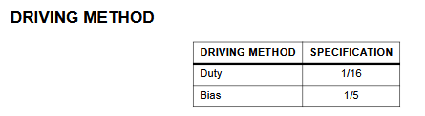
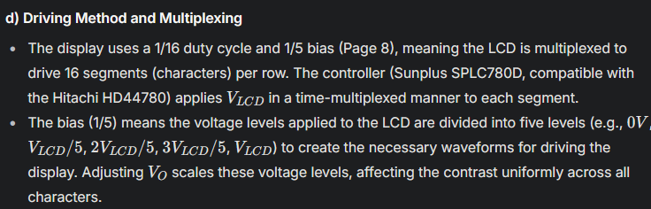

Aliexpress components:

SMD P-channel MOSFETs: 100PCS BSS84 BSS84LT1G SOT23 P channel field effect transistor New Original

Through hole: 10PCS IRF4905 IRF4905PBF TO-220 MOS FET P channel field effect 74A 55V 200W Triode Transistor IC

Display Dimensions:
https://app.diagrams.net/#G1dWtJceX1EF0UVBIALloe_9-uZIRbf27v#%7B%22pageId%22%3A%22xRkQWnxq37CqTRoY3F4O%22%7D

(Manually with the nice digital calipers)

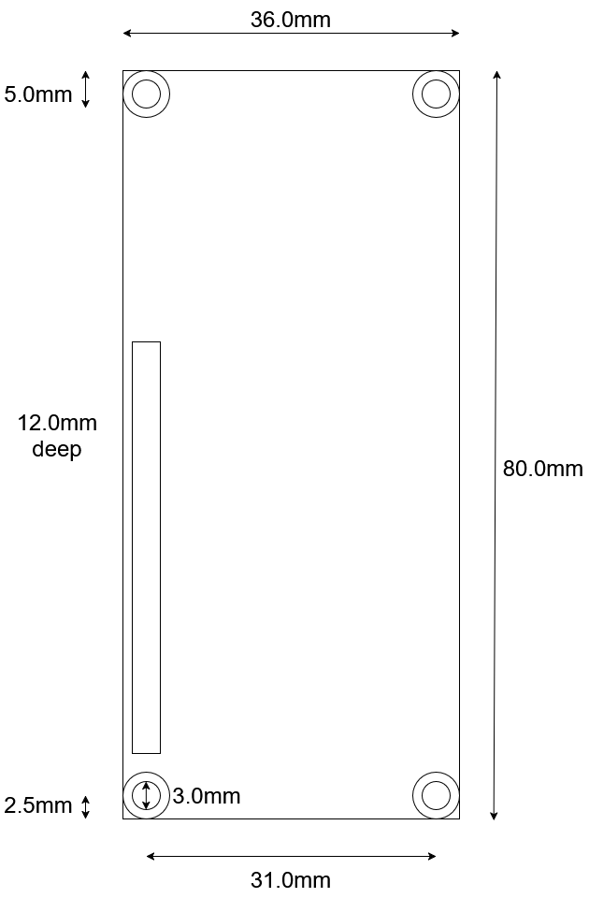

Shouldn’t have trusted that 3D model, I think i consulted a datasheet too
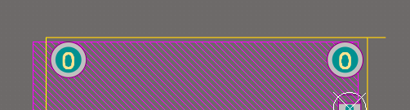

Yea the datasheet says 38x100 mm which is wrong. Why did I do 80mm?

Mar 30 2025
More David Palmer Questions:
https://x.com/DMOPalmer/status/1906352394226573438

Driving the display with 3.3V would require negative V0.

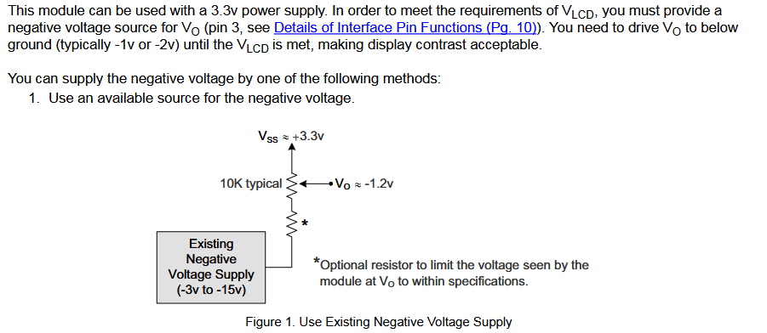

Palmer datasheet:
https://cdn.sparkfun.com/assets/9/5/f/7/b/HD44780.pdf
Page 46 has 4-bit startup commands.

Oops, PA2 and PA3 need to be reserved for UART on this Nucleo. Overlapping with D7 and RW.

Design flaw Nine!!!

May 8 2025 - Art of Electronics
Going to use this circuit from The Art of Electronics to control 5V to the display:
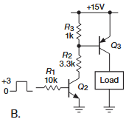

https://grok.com/chat/0d8b0c31-eb63-4413-9e30-fdcd02cea769

Things to consider:
- R3 and R2 can be 10k
- Add a resistor between gate of Q2 and ground
- Keep R1 10k
- The BSS84 P-channel MOSFET has 36 pF of Drain-Gate capacitance, t = RC = 10000 * 36e-12 = 3.6e-7 s
0.36us time constant. Low enough to not consider R in circuit design. Could go to 100k.
- V_{GS} threshold voltage is -0.9V to -2V
- R₃R₂ voltage divider must bring gate voltage below 3V (5-2). A 1:1 ratio will do this. But a 10k-100k system would not.
- Body diode is not a concern, since we have no reverse voltages and the display is always grounded
- R_{DS} is 4.7-10 ohms.
- R_{DS} decreases for higher voltages and increases for higher temperatures.
- Determine LCD current draw to determine if R_{DS} will cause a significant enough voltage drop to care.
- For I = 10mA and R = 5, V = 0.05V, insignificant. For I = 100mA, V = 0.5V, it’s significant.

The Through-hole P channel MOSFET has V_{gs(th)} = -2V (min), -4V (max).
The -1.7V for 3.3V GPIO and 5V power would work here.

The SMD P-channel MOSFET has V_{gs(th)} = -0.9V (min), -2V (max).
-1.7V doesn’t work here, only in the max case would it work.

I need to get gate voltage of the P-channel to 4.1V and 0V to toggle off/on.

From testing (see photos):
- Voltage drop over the MOSFET is 0V.
- It draws 1mA

This corresponds with 0.005V voltage drop due to Rds, which we’re not even seeing, great news.

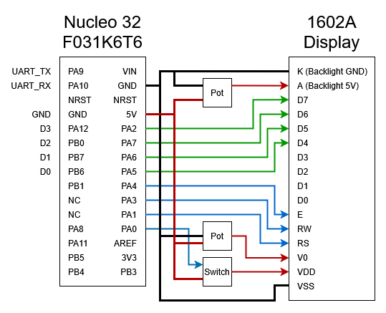

Note: PA9 and PA10 don’t work for UART for some reason, look into this.

Add the voltage divider for contrast too! Not actually required because we’re using a trimmer potentiometer.

Full contrast range:
4k -> 0k resistance

Not visible: 8.2k

So a 10k pot is exactly what’s needed, as the datasheet recommends

May 19 2025 - The PCB is Here!!

Gonna solder it all together straight away.

Was on my way to the gym when I saw it on my doorstep, listening to Revolutions Season 12 on Mars with a scrubbed F9 Starlink launch.

